
Western Australian Certificate of Education
Semester One Examination, 2019

Question/Answer Booklet
 | Total | Result | _____%
Section One | 52
Section Two | 98
Total | 150

MATHEMATICS
SPECIALIST
UNIT 1&2

Section One:
Calculator- free

Student’s Name: _______________________________________
As shown on your exam timetable

Student’s Teacher Mr Bradbury Mrs Waddell
(Circle your teacher’s name.)

Time allowed for this section
Reading time before commencing work: five minutes
Working time for this section: fifty minutes

Materials required/recommended for this section
To be provided by the supervisor
This question /Answer Booklet
Formula Sheet

To be provided by the candidate
Standard Items: pens (blue/black preferred), pencils (including coloured), sharpener,
correction fluid/tape, eraser, ruler, highlighters.
Special items: nil.

Important note to candidates
No other items may be taken into the examination room. It is your responsibility to ensure
that you do not have any unauthorized notes or other items of a non-personal nature in the
examination room. If you have any unauthorized material with you, hand it to the supervisor
before reading any further.

Section | Number of questions available | Number of questions to be answered |  | Working time (minutes) | Marks available | Percentage of exam
Section One:  Calculator-free | 8 | 8 |  | 50 | 52 | 35
Section Two:  Calculator-assumed | 13 | 13 |  | 100 | 98 | 65
 |  |  | Total |  | 150 | 100

Instructions to candidates

- The rules for the conduct of examinations are detailed in the School Examination Rules provided with your exam timetable. Sitting this examination implies that you agree to abide by these rules.

- Write your answers in this Question/Answer Booklet.

- You must be careful to confine your responses to the specific questions asked and to follow any instructions that are specific to a particular question.

- Spare pages are included at the end of this booklet. They can be used for planning your responses and/or as additional space if required to continue an answer.
- Planning: If you use the spare pages for planning, indicate this clearly at the top of the page.
- Continuing an answer: If you need to use the space to continue an answer, indicate in the original answer space where the answer is continued, i.e. give the page number. Fill in the number of the question(s) that you are continuing to answer at the top of the page.

- Show all your working clearly. Your working should be in sufficient detail to allow your answers to be checked readily and for marks to be awarded for reasoning. Incorrect answers given without supporting reasoning cannot be allocated any marks. For any question or part question worth more than two marks, valid working or justification is required to receive full marks. If you repeat an answer to any question, ensure that you cancel the answer you do not wish to have marked.

- It is recommended that you do not use pencil, except in diagrams.

- The formula sheet and your notes are not to be handed in with your Question/Answer Booklet.

Section One: Calculator-free 35% (52 Marks)
This section has eight (8) questions. Answer all questions. Write your answers in the spaces provided.

Working time: 50 minutes.

Question 1 (4 marks)
In the diagram below (not drawn to scale) $A, B$ and $C$ lie on the circle with centre $O$ and $OA$ is parallel to $CB$.
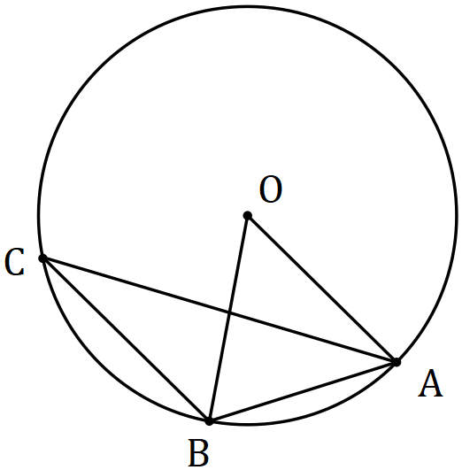

Determine, with reasons, the size of $∠OBA$ and the size of $∠ABC$ when $∠OAC=23°$.

Question 2 (8 marks)
Let $a=4i-8j$, $b=-3i+6j$ and $c=2i+3j$.

(a) Determine

(i) $b-c$. (1 mark)

(ii) $3b+4a$. (2 marks)

(iii) $|a+c|$. (2 marks)

(b) Determine a unit vector that is parallel to $a+b$ but in the opposite direction. (3 marks)

Question 3 (6 marks)
(a) Body $A$ moves $40$ m on a bearing of $315°$. Express this displacement in component form using unit vectors $i$ and $j$ and exact values. (3 marks)

(b) Body $B$ moves with a velocity of $4\sqrt{3}i-4j$ ms⁻¹. Determine the speed of this body and the bearing it is travelling in. (3 marks)

Question 4 (7 marks)
Quadrilateral $ABCD$ is shown below. The midpoints of sides $AB, BC, CD$ and $DA$ are $P, Q, R$ and $S$ respectively. Let $\vec{AB}=2b, \vec{AC}=2c$ and $\vec{AD}=2d$.

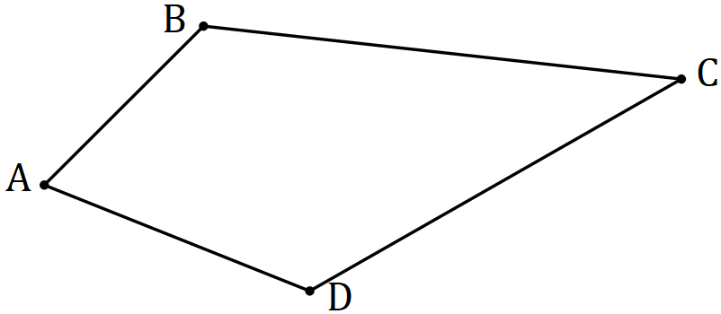

(a) Sketch quadrilateral $PQRS$ on the diagram above. (1 mark)

(b) Determine expressions for $\vec{AQ}, \vec{AR}$ and $\vec{QR}$ in terms of $b, c$ and $d$. (3 marks)

(c) Prove that $\vec{PQ}=\vec{SR}$ and $\vec{PS}=\vec{QR}$. (3 marks)

Question 5 (6 marks)
Consider the following statement that refers to two isosceles triangles.

If the triangles have the same area, then the triangles are congruent.

(a) Write the inverse statement and state whether it is true or false. (2 marks)

(b) Write the converse statement and state whether it is true or false. (2 marks)

(c) Write the contrapositive statement and use a counter-example to explain why it is false.
(2 marks)

Question 6 (7 marks)
(a) The work done, in joules, by a force of $F$ Newtons in changing the displacement of an object by $s$ metres, is given by the scalar product of $F$ and $s$. Determine the work done by

(i) force $F=\left(10i+8j\right)$ N that moves a small body from $\left(2i-8j\right)$ m to $\left(15i+12j\right)$ m.
(2 marks)

(ii) a horizontal force of $30$ N that pushes a small body $1.8$ m up a slope inclined at $30°$ to the horizontal. (2 marks)

(b) Determine the vector projection of $\left(2i+4j\right)$ on $\left(-3i+4j\right)$. (3 marks)

Question 7 (6 marks)
In the diagram below (not drawn to scale), two circles intersect at $F$ and $G$. $AH$ is a tangent to the circle at $H$. $AE$ is a straight line that cuts the circles at $A, B, D$ and $E$ and intersects chord $GF$ at $C$.
$AB=8, GC=4.5, CF=2$, $AH=12$ and $BC<CE$.

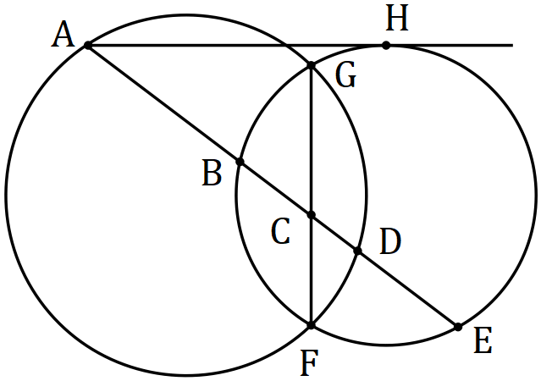

(a) Deduce that $BE=10$. (2 marks)

(b) Determine $BC$ and $CD$, justifying your answers. (4 marks)

Question 8 (8 marks)
(a) Evaluate $\begin{matrix} ^{2020}P_{2} \\ \overline{{101× }^{20}P_{1}}\end{matrix}$. (3 marks)

(b) Given that $^{n+1}P_{r}=k× ^{n}P_{r}$, determine the constant $k$ in terms of $n$ and/or $r$. (3 marks)

(c) Given that $^{14}P_{12}=43 589 145 600$, determine $^{16}P_{12}$. (2 marks)

Additional working space.

Question Number _________

Additional working space.

Question Number: _________

